LAB EXPERIMENT RECORD
Set 26: Student Performance Data

Department | AIML
Course Code / Course Name | DSA0601 / Data Handling and Visualization
Experiment | Data Visualization using R
Name | G. GANGA CHANDRIKA
Register Number | 1925260144
Date | 20 October 2026
Day | Tuesday

Aim
To visualize student performance data using a histogram, boxplot, scatter plot with regression line and monthly trend line chart in R, and to build an interactive dashboard in Tableau.
Dataset: Student_Mini_Data.csv
Student_ID | Gender | Study_Hours | Attendance | Math_Score | Science_Score | Exam_Date
S01 | Male | 2.0 | 78 | 62 | 65 | 2025-01-10
S02 | Female | 3.5 | 90 | 80 | 85 | 2025-01-10
S03 | Male | 1.5 | 70 | 55 | 58 | 2025-02-12
S04 | Female | 4.0 | 95 | 90 | 92 | 2025-02-12
S05 | Male | 2.8 | 85 | 72 | 74 | 2025-03-15
S06 | Female | 3.0 | 92 | 82 | 86 | 2025-03-15

PROGRAM 1: Histogram of Math Score and Boxplot of Science Score by Gender
Import the dataset in R. Plot a histogram for Math_Score and draw a boxplot of Science_Score by Gender. Add proper titles and labels, and interpret the results.
# Load library
library(ggplot2)
# Create dataset
student <- data.frame(
Student_ID = c("S01", "S02", "S03", "S04", "S05", "S06"),
Gender = c("Male", "Female", "Male", "Female", "Male", "Female"),
Study_Hours = c(2.0, 3.5, 1.5, 4.0, 2.8, 3.0),
Attendance = c(78, 90, 70, 95, 85, 92),
Math_Score = c(62, 80, 55, 90, 72, 82),
Science_Score = c(65, 85, 58, 92, 74, 86),
Exam_Date = as.Date(c(
"2025-01-10", "2025-01-10",
"2025-02-12", "2025-02-12",
"2025-03-15", "2025-03-15"
))
)
# Histogram of Math Score
ggplot(student, aes(x = Math_Score)) +
geom_histogram(binwidth = 10, fill = "skyblue",
color = "black") +
labs(title = "Distribution of Mathematics Scores",
x = "Math Score",
y = "Number of Students") +
theme_minimal()
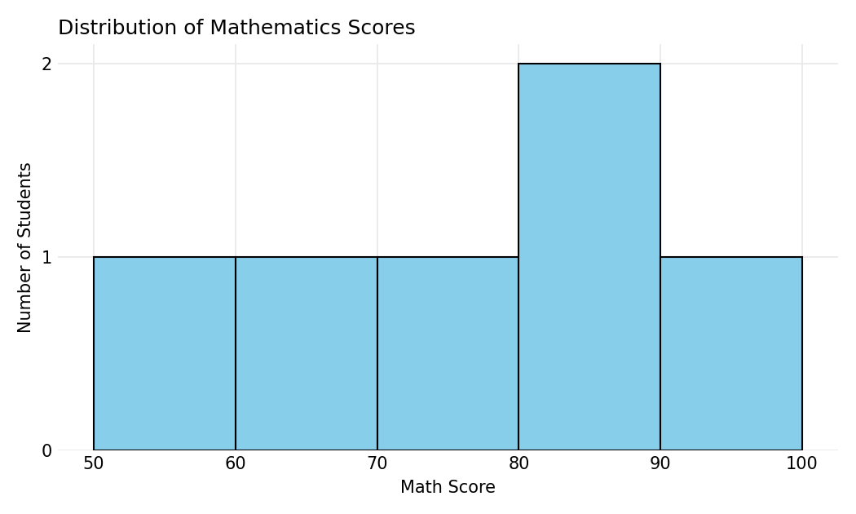
Output 1a: Distribution of Mathematics Scores
# Boxplot of Science Score by Gender
ggplot(student, aes(x = Gender, y = Science_Score,
fill = Gender)) +
geom_boxplot() +
labs(title = "Science Scores by Gender",
x = "Gender",
y = "Science Score") +
theme_minimal()
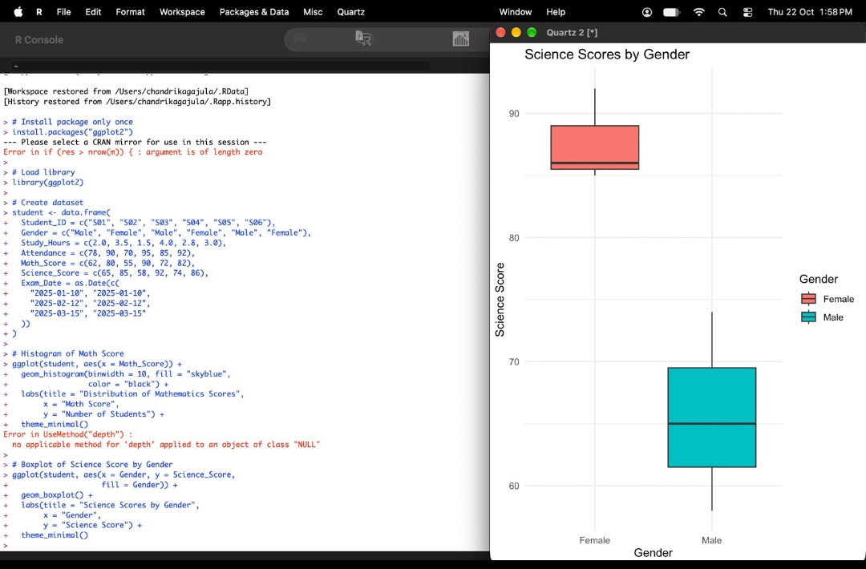
Output 1b: Science Scores by Gender (Boxplot)
Interpretation: Math scores range from 55 to 90, with most students scoring between 60 and 90 and no extreme outliers. In the boxplot, female students have clearly higher Science scores (median about 86, range 85 to 92) than male students (median about 65, range 58 to 74). The two boxes do not overlap, so female students performed better in Science in this sample.

PROGRAM 2: Scatter Plot of Study Hours vs Math Score
Create a scatter plot between Study_Hours and Math_Score using different colors for Gender. Add a regression line and explain the relationship between study time and performance.
# Scatter plot with regression line
ggplot(student, aes(x = Study_Hours, y = Math_Score)) +
geom_point(aes(color = Gender), size = 3) +
geom_smooth(method = "lm", se = FALSE, color = "black") +
labs(title = "Study Hours vs Math Score",
x = "Study Hours",
y = "Math Score") +
theme_minimal()
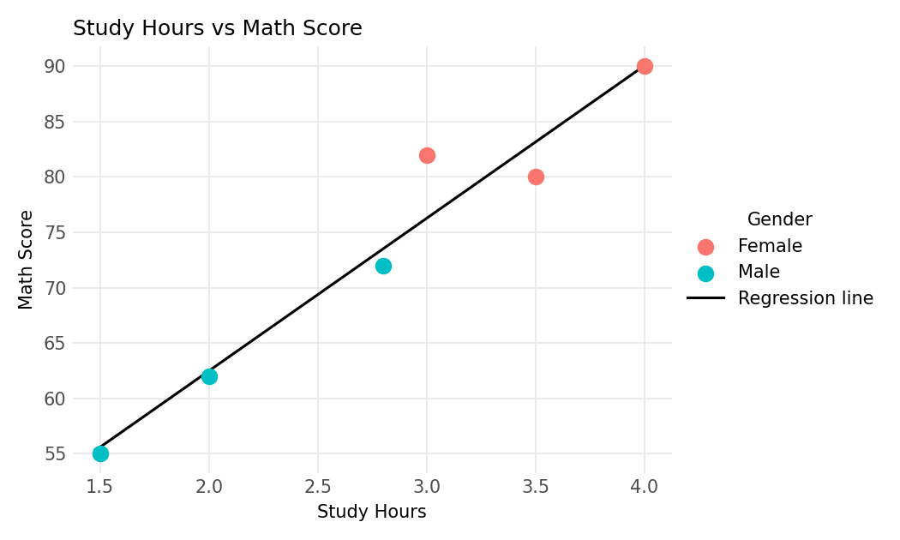
Output 2: Study Hours vs Math Score with Regression Line
Relationship: The points rise from the lower left to the upper right and lie close to the fitted line (correlation r = 0.97). Each extra hour of study is associated with roughly 13.8 more marks in Math. Students who study 1.5 to 2.8 hours score between 55 and 72, while those who study 3.5 to 4 hours score between 80 and 90, so more study time is strongly associated with better performance in this small sample.

PROGRAM 3: Monthly Average Math Score Trend with Moving Average
Convert Exam_Date into Date format, calculate monthly average Math scores, plot a line chart for the trend, apply moving average smoothing and identify any increasing or decreasing pattern.
# Convert Exam_Date to Date format
student$Exam_Date <- as.Date(student$Exam_Date)
# Extract month
student$Month <- format(student$Exam_Date, "%Y-%m")
# Calculate monthly average Math scores
monthly_avg <- aggregate(
Math_Score ~ Month,
data = student,
FUN = mean
)
# Calculate 2-month moving average
monthly_avg$Moving_Average <- c(
NA,
(monthly_avg$Math_Score[1] +
monthly_avg$Math_Score[2]) / 2,
(monthly_avg$Math_Score[2] +
monthly_avg$Math_Score[3]) / 2
)
# Display results
print(monthly_avg)
# Plot monthly average and moving average
ggplot(monthly_avg, aes(x = Month, group = 1)) +
geom_line(aes(y = Math_Score, color = "Monthly Average"),
linewidth = 1) +
geom_point(aes(y = Math_Score), size = 3) +
geom_line(aes(y = Moving_Average, color = "Moving Average"),
linewidth = 1, na.rm = TRUE) +
labs(title = "Monthly Math Score Trend",
x = "Month",
y = "Average Math Score",
color = "Legend") +
theme_minimal()
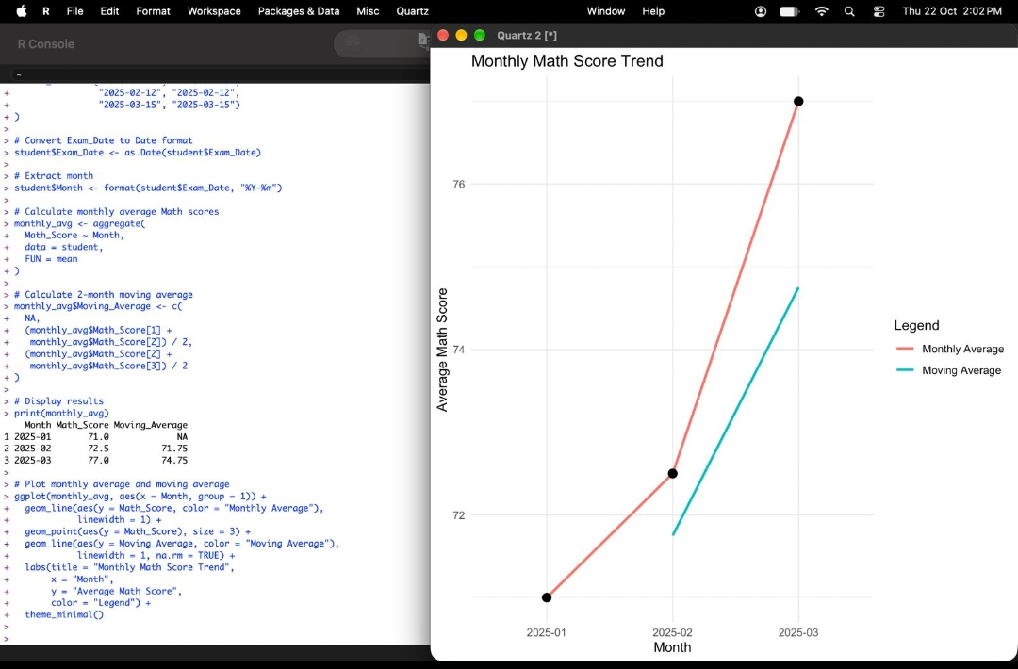
Output 3: Monthly Math Score Trend with Moving Average
Observation: The monthly average Math score rises from 71.0 in January to 72.5 in February and 77.0 in March. The 2-month moving average (71.75 and 74.75) also increases. The trend is therefore consistently increasing, with the sharpest rise between February and March.

PROGRAM 4: Interactive Student Performance Dashboard in Tableau
Import Student_Mini_Data.csv into Tableau. Create a bar chart of average Math scores by Gender, a line chart of score trends over time, add a filter for Exam_Date and design a simple interactive dashboard.
1. Connect to Text file in Tableau and import Student_Mini_Data.csv.
2. Sheet 1: drag Gender to Columns and Math_Score to Rows, then change the aggregation to Average and colour by Gender (bar chart).
3. Sheet 2: drag Exam_Date to Columns (Exact Date) and Math_Score (Average) to Rows to create the line chart of score trend.
4. Right-click Exam_Date and choose Show Filter to add the date range filter.
5. Create a new Dashboard, drag both sheets onto it, and set the Exam_Date filter to apply to all worksheets.
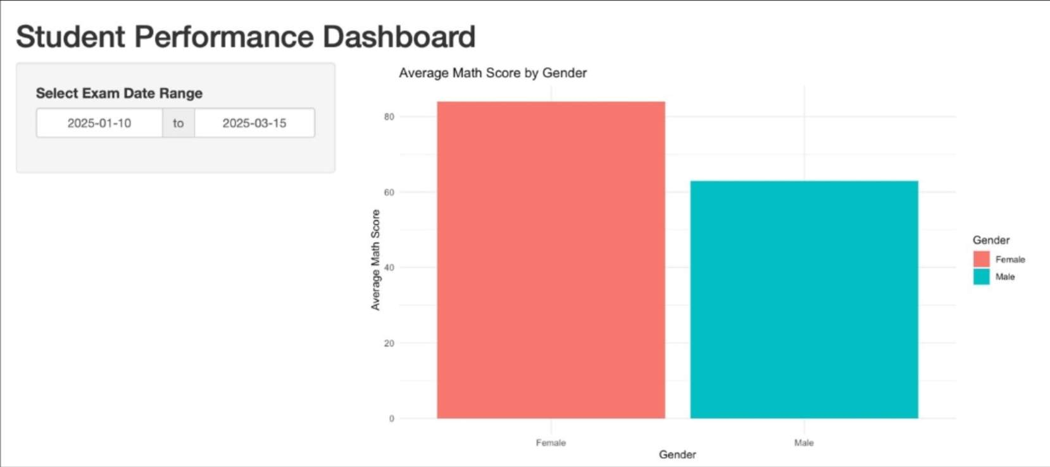
Output 4a: Student Performance Dashboard (Bar Chart and Date Filter)
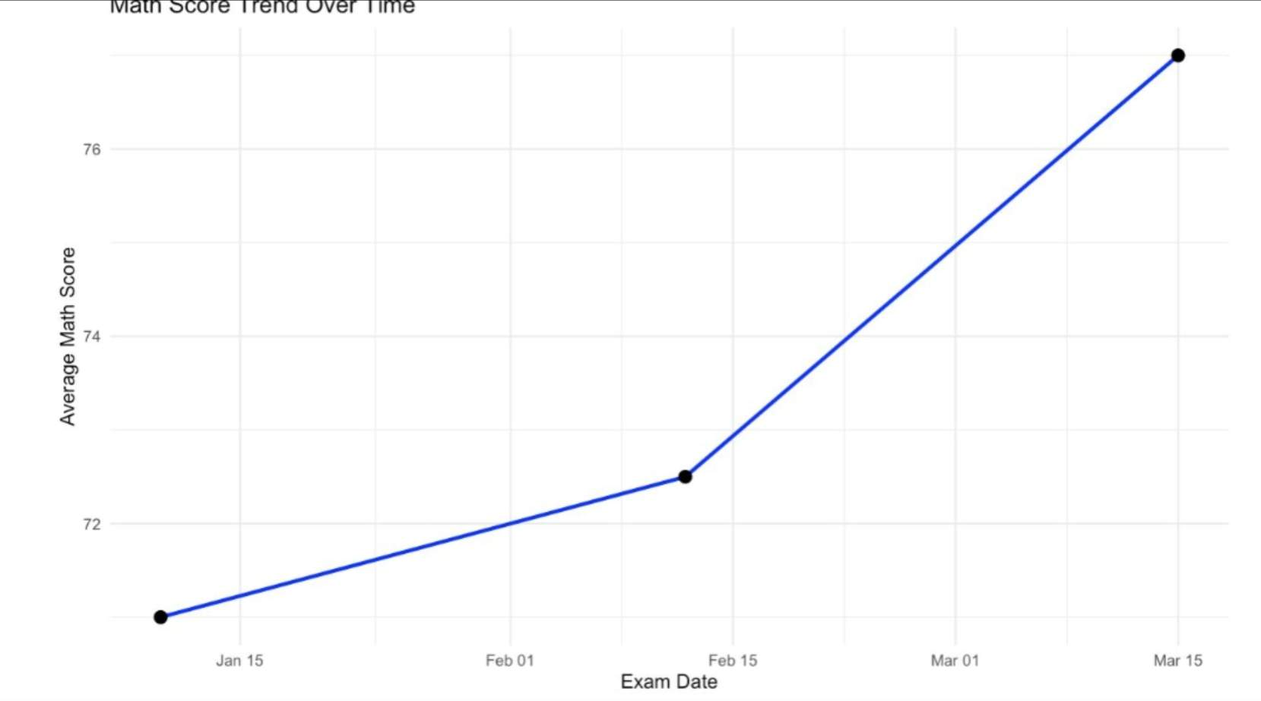
Output 4b: Math Score Trend Over Time (Line Chart)
Observation: Between 2025-01-10 and 2025-03-15, female students average about 84 in Math compared with about 63 for male students. The line chart shows the average Math score rising from 71 on 10 January to 72.5 on 12 February and 77 on 15 March. Changing the Exam_Date range updates both charts.

Procedure
1. Create the student data frame in R with Exam_Date stored as Date.
2. Use ggplot2 with geom_histogram() and geom_boxplot() to plot Math_Score and Science_Score by Gender.
3. Use geom_point() with colour by Gender and geom_smooth(method = "lm") to draw the scatter plot with regression line.
4. Convert Exam_Date, extract the month, use aggregate() for monthly averages and compute the 2-month moving average to plot the trend.
5. Import the CSV into Tableau, build the bar chart and line chart, add the Exam_Date filter and combine them in a dashboard.
Result
The student performance data was successfully visualized in R using a histogram, boxplot, scatter plot with regression line and a monthly trend line with moving average. An interactive dashboard with a bar chart, line chart and Exam_Date filter was created in Tableau.
Key R Functions Used
Function | Purpose
data.frame() | Creates the student dataset.
as.Date() | Converts Exam_Date into Date format.
format() | Extracts the year-month from a date.
aggregate() | Calculates monthly average Math scores.
ggplot() | Creates the base plot.
geom_histogram() / geom_boxplot() | Draw the histogram and boxplot.
geom_point() / geom_smooth() | Draw the scatter plot and regression line.
geom_line() | Draws the monthly and moving-average trend lines.

